**Server Requirement**

**Specification**

**for**

**Data for Policy in Food Systems Geospatial Platform**

mistEO Private Limited

Submitted to



27.01.2022

## **Solution Architecture**

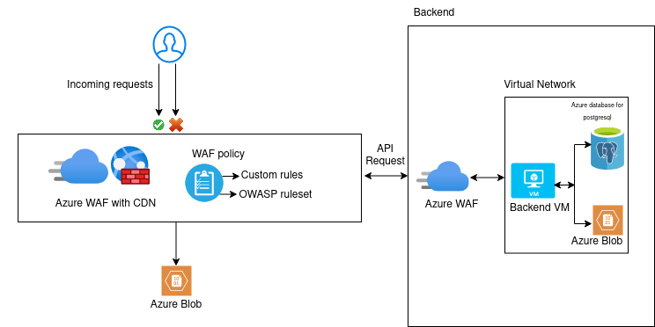

## **Server Specification**

1. Virtual machine B4ms (4 vCPUs, 16 GB RAM) - Dev Server

Authentication method: .pem file

Operating system: Ubuntu 18.04

Inbound Ports: All traffic

IP : Static IP

2. Virtual machine 1 B8ms (8 vCPUs, 32 GB RAM) - Backend server

Authentication method: .pem file

Operating system: Ubuntu 18.04

Inbound Ports: 443, 80

IP: Static IP

3. IP Addresses

2 Static IP for API server & dev server

4. Azure Monitor (Alternative for amazon cloudwatch)

Monitor web applications

Monitor Infrastructure

Based on various monitoring we can setup alerts

5. Notification Hubs (Alternative for amazon simple notification service SNS)

6.Azure Database for PostgreSQL

Version : 11

Tier : General purpose

Compute : Gen 5, 2 vCore

Storage : 30 GB

Additional Backup storage : 30 GB

Whitelist Backend server ip on this

7. Application Gateway (Alternative for AWS WAF)

Web application Firewall on Application Gateway.It helps to protect our web application or APIs against common web exploits and bots that may affect availability , compromise security, or consume excessive resources this will implement on both frontend and backend server

8. Content Delivery Network (Alternative for Amazon cloud front)

This can be used in Azure blob . by using its rule engine where we can configure URL rewrites which effectively matches patterns of the url and internally routes traffic elsewhere without affecting the client side URL

9.Storage Accounts (Alternative for AWS S3)

* Capacity 1 TB for storing layers data

Type : Block Blob Storage

Performance Tier: Standard

Storage Account Type: General Purpose V2

Access tier: HOT

Redundancy: LRS

Credentials needed to write data from the code

connection string

storage account name

Container

* Capacity 1 GB for hosting front end app

Type : Block Blob Storage

Performance Tier: Standard

Storage Account Type: General Purpose V2

Access tier: HOT

Redundancy: LRS

## **Reference**

<https://azure.com/e/9a3a2dc45b3d4a9bb9a071675e5127b0>

## **Notes**

**Secure communication between API Server VM and Azure Blob**

On the container settings select option for change access level menu and select  
Public access level : Blob (Anonymous read access for blob only)

To restrict public access only inside VM we need to do the following

On the settings of storage accounts select Networking -> Firewalls and virtual networks -> Selected Networks -> Select the same virtual network which the api virtual machine have (api vm and the storage account should be in the same virtual network)